| **ASSESSMENT HANDOUT**  **Portfolio of Exercises 1** |  |
| --- | --- |

| **MODULE CODE** | CCS1100 |
| --- | --- |
| **MODULE TITLE** | Continuous Mathematical Foundations |
| **PROGRAMME** | Bsc (Hons) in Computer Science |
| **DEPARTMENT** | Computer Science |
| **CREDITS** | 10 |
| **STAGE OF STUDY** | 1 |
| **SEMESTER/SESSION** | Fall 2021-2022 |
| **LOCATION** | Thessaloniki |
| **STAFF** | Dr. Georgios Stagakis |
| **E-MAIL** | gstagakis@york.citycollege.eu |
| **STAFF OFFICE** | 7th floor |
| **ACCREDITATION** | The programme is accredited:  the British Computer Society |

| **ASSESSMENT NUMBER** | 1 |
| --- | --- |
| **CONTRIBUTION** | 10% of the module final mark |
| **ASSESSMENT TITLE** | Portfolio of Exercises 1 |
| **ASSESSMENT TYPE** | Portfolio |
| **HAND-OUT DATE** | Week 2: 20/10/2021 |
| **SUBMISSION DATE** | Week 4: 06/11/2021 |
| **FEEDBACK DATE** | Week 5: 12/11/2021 |

| **LEARNING OUTCOMES** |  |
| --- | --- |
| LO5 | Process data to demonstrate its properties, by summarizing it in the form of a histogram, frequency table and by calculating the mean, median, mode, variance and standard deviation. |
| LO7 | Calculate probabilities for (in)dependent events, (non)mutually exclusive events using the appropriate theory. |
| LO8 | Determine the distribution of a discrete or continuous random variable, by correctly interpreting the information provided in a probability distribution problem. |

| **ASSESSMENT CRITERIA** |
| --- |
| The criteria on which the students will be assessed are as follows:   * Comprehensiveness and clear understanding of the main theoretical perspectives and empirical methodologies employed in the relevant literature. * Collection and transformation of the required data. * Ability to analyse/discuss statistical findings. * Ability to prototype phenomena that bear randomness through set theory and probability functions. |

| **DETAILED DESCRIPTION** |
| --- |

Please provide solutions for the following exercises:

1. A company needs extra hard disks for adaptions in its main database.

Its employees used augmented insights in order to gather models with

their respective price and storage from the main providers of the market.

Below there is a scatter plot where each disk is represented by a dot in the

position arranged by its price and storage capacity. They have divided

the scatter plot in 4 parts with red dotted lines.

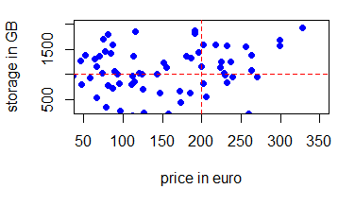

1. Please state for each block its position, if the disks of the block are

cheap or expensive in comparison with the rest of the blocks and if the

storage capacity is high or low.

Please use the format,

“top/bottom-right/left block — cheap/expensive — low/high”

and give your answer in 4 lines, 1 for each block.

1. From which block would you pick your hard drive? Please explain why

briefly.

1. A mail service company needs a super computer in order to handle the

daily tasks of their service. Its council needs to decide between two offers,

the green or the grey system. Below it is a histogram of the tasks each

computer handles in a second.

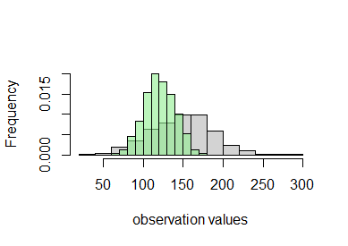

1. Which computer has highest mean and which the highest variance?
2. If you had to choose your option based on the highest average perfor-

mance which would be your answer?

1. Technically if the performance is less than 50, the computer fails and

needs service. If you want to avoid this case scenario at all cost which

would be your choice?

1. For the sample below you have to calculate the mean, median and variance.

You can double check your answer in R programming language.

15, 21, 17, 25, 20, 28, 22, 15, 17, 25,

10, 19, 22, 13, 21, 20, 29, 18, 7, 14.

Please note that in the class we calculated the measures for 5 values. Now

that the values are 20 the calculation is more complicated. In our day

and age, using statistical methods for professional applications by hand,

instead of a computer language, is almost infeasible.

1. The following image is also included in google classroom - assessment, named “color.bmp”.

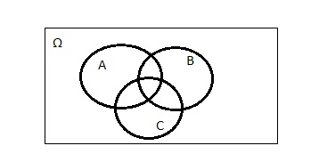

Please open it with a paint app such as “Windows Paint” or draw it by

yourself and provide a photo and

1. Paint in grey the part of Ω that is equal to {Ω \ (A ∪ B ∪ C)}.
2. Paint in red {A ∩ B ∩ C}.
3. Paint in green {(A \ B) ∪ (B \ A)}.
4. You have visited a fortune teller in order to get feedback about your distant

future. The fortune teller specializes in reading tarot cards, out of the

classical major arcana deck that is consisted by 22 cards - 12 positive luck

cards and 10 negative.

1. Please describe the probability space (Ω, F, P) in terms of Ω, F and P

for the first draw, if it will be lucky or not. Are the probabilities in favor for you to have a fortunate prediction?

1. Given that you have already draw 3 lucky cards and 2 unlucky, what

is the probability of drawing a lucky card next? You might have noticed

that after drawing 5 cards you have a conditional probability space where

the first 5 draws are given. Please give your answer as the conditional

probability notation (P(·|·)) and what is equal to.

1. You are asked along with your 6th draw to toss the “Coin of Fate”. If

the result is “star” the sixth draw is more important than the previous

or else the previous cards are in effect. What is the (joint) probability to have a

lucky card and “star” as outcome?

| **SUBMISSION** |
| --- |
| Students are expected to submit:   * to TurnitIn, by 06-11-2021, 21:00.   **Late Submission Policy**: All work submitted late, without an approved claim of extension or exceptional circumstances, will result in a 10 marks reduction for each day that the work is late, up to a total of five days, including weekends and bank holidays. |

| **NOTE** |
| --- |
| *This piece of assessment should be completed and submitted by the student (or group of students in group work) without assistance from or communication with another person either external or fellow student (outside the group). All sentences or passages cited in the assignment from other people's work should be specifically acknowledged by complete and accurate reference to the author, work and page(s). Failure to abide by the above regulation constitutes use of unfair means (collusion, plagiarism etc.) and will result in a fail mark for this work. It might also invoke disciplinary actions. It is at the instructor’s discretion to conduct an oral examination, which will result in the award of the final grade for that particular piece of assessment.* |

| **TURN IT IN REQUIREMENT** |
| --- |
| This piece of assessment is required to be submitted to **turnitin** plagiarism detection software at:  [**www.turnitin.com**](http://www.turnitin.com)  at a date no later than the submission date. This is an absolute requirement for releasing a mark. Brief instructions on how you can set up your profile and submit your work can be found at:  [**https://help.turnitin.com/feedback-studio/turnitin-website/student/student-category.htm**](https://help.turnitin.com/feedback-studio/turnitin-website/student/student-category.htm)(text)  [**https://youtu.be/AC3GB-FOMvY**](https://youtu.be/AC3GB-FOMvY)(video)  You are going to require:   | **CLASS ID:** | **32213954** | **ENROLLMENT PASSWORD:** | **m2wytgr** | | --- | --- | --- | --- |   If you have any problems in submitting your work, please contact the course administrator or the module leader. |